The Nest at CRC
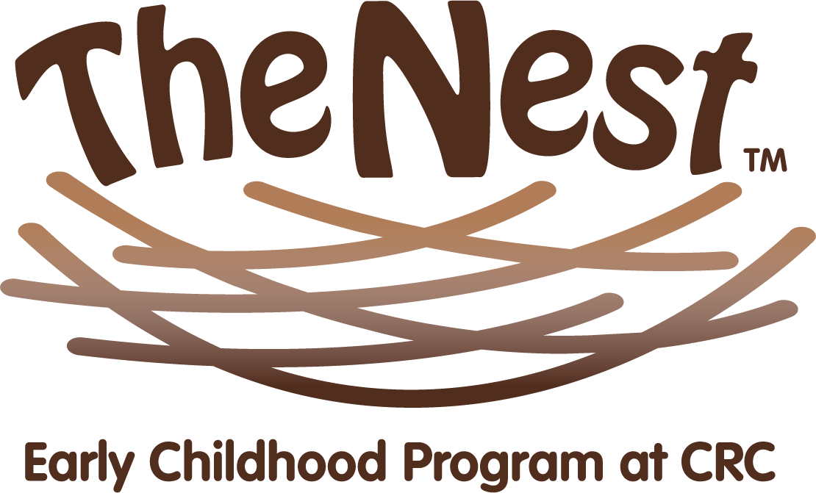
Early Childhood Education Program at CRC

Thank you for your interest in The Nest at Central Reform Congregation.

The Nest at CRC offers full time care for families with children ages 6 weeks to 5 years. To apply, please return this form with a nonrefundable application fee of $75.00 payable to The Nest at CRC. When your application and fee are received, you will be placed in a wait pool. Acceptance into the program is based on application date, child’s age, and availability of space.

Child’s Information
Child’s Name ___________________________________________________________Date of Birth ___________________________________________________

Child’s Name ___________________________________________________________Date of Birth ___________________________________________________

Family/Guardian Information

Name ___________________________________________________________________Name_____________________________________________________________

Relationship ___________________________________________________________Relationship _____________________________________________________

Address ________________________________________________________________Address __________________________________________________________

City and Zip____________________________________________________________ City and Zip______________________________________________________

E-mail __________________________________________________________________Email_____________________________________________________________

Contact phone ________________________________________________________Contact phone____________________________________________________

CRC Member Yes No CRC Member Yes No

Date you would be interested in enrolling your child: ________________________________________________________________________________

Please return this form and a check payable to The Nest at CRC:
Director of The Nest
5020 Waterman Blvd
St. Louis, MO 63108

For more information and to schedule a visit contact Maxine Weil at 314-361-1564 x 118 or Thenest@centralreform.org

Family/Guardian’s Signature ________________________________________________Date __________________________________________________

For Administration

Date Received _________________________Date Entered ______________ Check Number ________________ Amount _________________

