The Nest at CRC

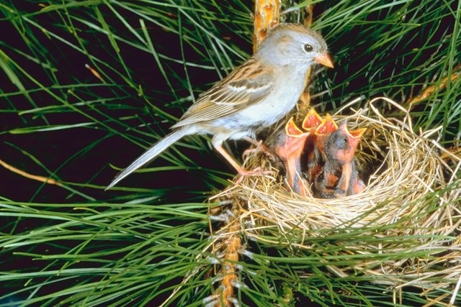
Early Childhood Education Program at CRC

Thank you for your interest in The Nest at Central Reform Congregation. The Nest offers full time care for families with children ages 6 weeks to 6 years of age. To apply, please return the form with a non-refundable application fee of $75.00, payable to The Nest at CRC. When your application and fee is received, you will be placed in a wait pool. Acceptance into the program is based on application date, child’s age, and availability of space.

Child’s Information
Child’s Name _________________________________________________________________________Date of Birth _____________________

Child’s Name _________________________________________________________________________Date of Birth _____________________

Family/Guardian Information

Name _________________________________________________ Name_______________________________________________________________

Relationship ____________________________________________ Relationship ______________________________________________________

Address _________________________________________________ Address ___________________________________________________________

City and Zip_____________________________________________ City and Zip________________________________________________________

E-mail ___________________________________________________ Email ______________________________________________________________

Contact phone _________________________________________ Contact phone______________________________________________________

CRC Member Yes No CRC Member Yes No

Please return this form and a check payable to The Nest at CRC:
Sally Brown, Director of the Nest
5020 Waterman Blvd
St. Louis, MO 63108

For more information and to schedule a visit contact Sally Brown at 314-361-1564 x 115or Thenest@centralreform.org.

Family/Guardian’s Signature _______________________________________________Date ___________________________

Administration

Date Received ______________________________Date Entered ______________ Check Number ____________ Amount ____________

